1. Write a Java program to display the following pattern

*Sample Pattern :*

J a v v a

J a a v v a a

J J aaaaa V V aaaaa

JJ a a V a a

1. Write a Java program to print an American flag on the screen

Expected Output

\* \* \* \* \* \* ==================================

\* \* \* \* \* ==================================

\* \* \* \* \* \* ==================================

\* \* \* \* \* ==================================

\* \* \* \* \* \* ==================================

\* \* \* \* \* ==================================

\* \* \* \* \* \* ==================================

\* \* \* \* \* ==================================

\* \* \* \* \* \* ==================================

==============================================

==============================================

==============================================

==============================================

==============================================

==============================================

1. Write a Java program to answer about the statistical information such as arithmetic mean, median, mode, and standard deviation of an integer data set. The data points are input by the user from keyboard.

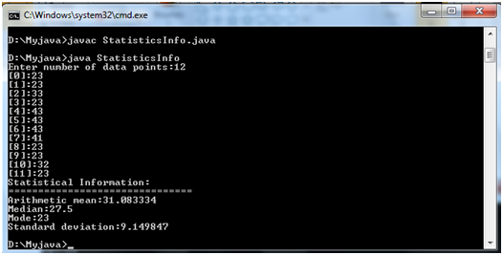

1. The process of finding the largest value (i.e., the maximum of a group of values) is used frequently in computer applications. For example, a program that determines the winner of a sales contest would input the number of units sold by each sales person. The sales person who sells the most units wins the contest. Write a Java application that inputs a series of 10 integers and determines and prints the largest integer.

Your program should use at least the following three variables:

a. counter: A counter to count to 10 (i.e., to keep track of how many numbers have been input and to determine when all 10 numbers have been processed).

b. number: The integer most recently input by the user.

c. largest: The largest number found so far.

5) Create a class called Invoice that a hardware store might use to represent an invoice for an item sold at the store. An Invoice should include four pieces of information as instance variables‐a part number(type String),a part description(type String),a quantity of the item being purchased (type int) and a price per item  (double). Your class should have a constructor that initializes the four instance variables. Provide a set and a get method for each instance variable. In addition, provide a method named getInvoice Amount that calculates the invoice amount (i.e., multiplies the quantity by the price per item), then returns the amount as a double value. If the quantity is not positive, it should be set to 0. If the price per item is not positive, it should be set to 0.0. Write a test application named InvoiceTest that demonstrates class Invoice’s capabilities.

6) Create a class called Employee that includes three pieces of information as instance variables—a first name (typeString), a last name (typeString) and a monthly salary (double). Your class should have a constructor that initializes the three instance variables. Provide a set and a get method for each instance variable. If the monthly salary is not positive, set it to 0.0. Write a test application named EmployeeTest that demonstrates class Employee’s capabilities. Create two Employee objects and display each object’s yearly salary. Then give each Employee a 10% raise and display each Employee’s yearly salary again.